### **Event Guest List Automation Iteration 0**

### **Team Members and Roles:**

* Asees (Product Owner)
* Dharmendra Baruah
* [Jiyoon Hwang](http://pro-assign.herokuapp.com/users/564)
* [Leon Lin](http://pro-assign.herokuapp.com/users/540)
* [Pavankumar Prakash Kakkanavar](http://pro-assign.herokuapp.com/users/505)
* [Suma Katabattuni](http://pro-assign.herokuapp.com/users/530)
* [Sunayna Ray](http://pro-assign.herokuapp.com/users/523) (Scrum Master)

### **Customer meeting:**

We had an online meeting(Zoom) with the client at 8.00 pm CST on October 21, 2021 in which we discussed about the customer requirement and user stories.

**Summary:**

The main requirement involves improvements in the guest list column synchronization and RSVP form customizability. One of the primary customer needs is recognizing entries placed in the Box Office List header to sync with the VIP Guest List column. When the admin adds a new VIP guest to the user interface, the guest counter in the guest column should increment. In addition, the VIP guest list should reflect the guest’s name, email, and seat category entered by the admin. Meanwhile, the consolidated portal page (which contains all the controls) should include an option to display both the guest list header and box office content. In addition, for each column on the page, the content in the guest list and box office should be aligned.

Another customer need is the ability of the customer to receive emails that contain embedded graphical content such as images or fancy text. Therefore, the application interface must include a preparation page to allow the admin to provide text details and insert images and logos into emails. These images would then appear in the guest’s confirmation email. In addition, the preparation form should also allow customization of outgoing RSVP forms.

### **Slack:**

### <https://join.slack.com/t/softwaresetsails/shared_invite/zt-xs5omsxd-9_Le825cNNT37sjdIaO9eA>

### **GitHub:** <https://github.com/sunayna-ray/Event-Guest-List-Automation>

### **Pivotal Tracker:** <https://www.pivotaltracker.com/invitations/welcome?invitation_guid=eab753b42a31495b9972999eaaac0df2__;!!KwNVnqRv!QUqIzOFOJz_nlZ-OZ6xlwBGW2vXH4sgb_OPFoV0RxHzMY20109omXgDxNbv1K58$>

**User Stories:**

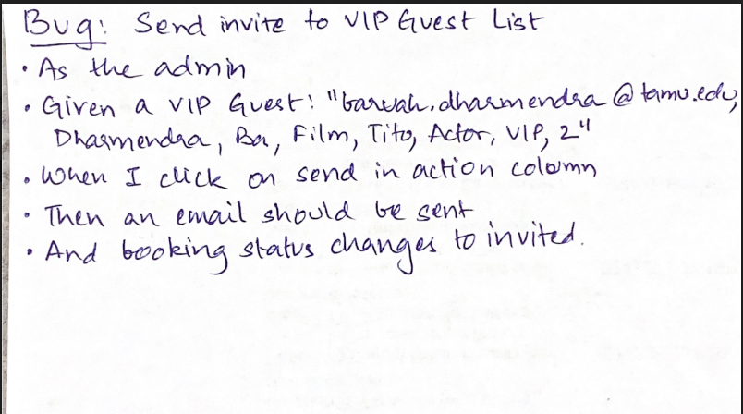 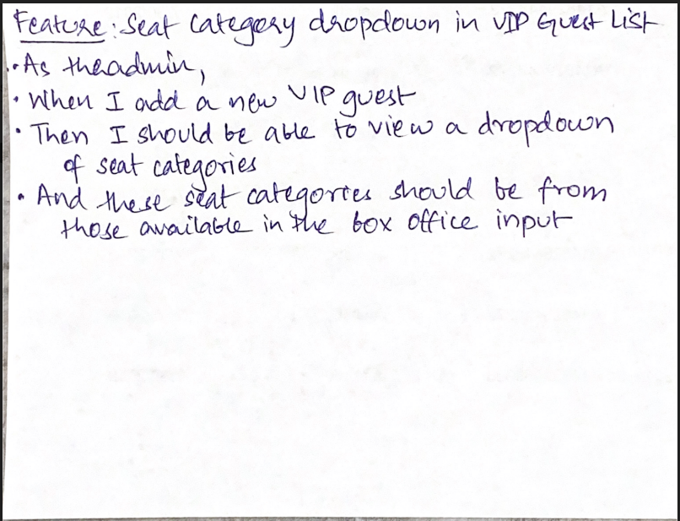

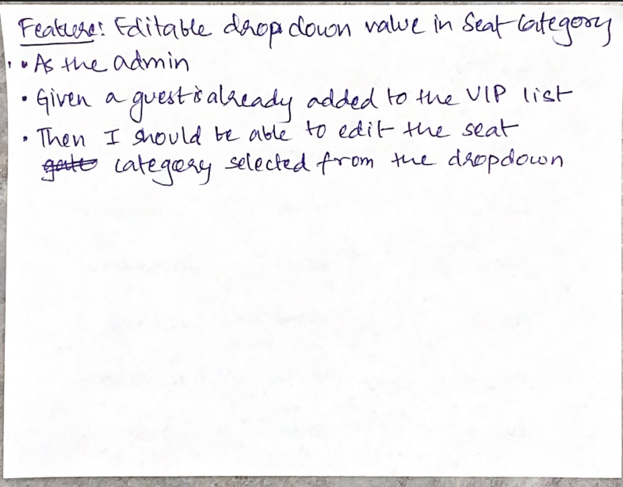 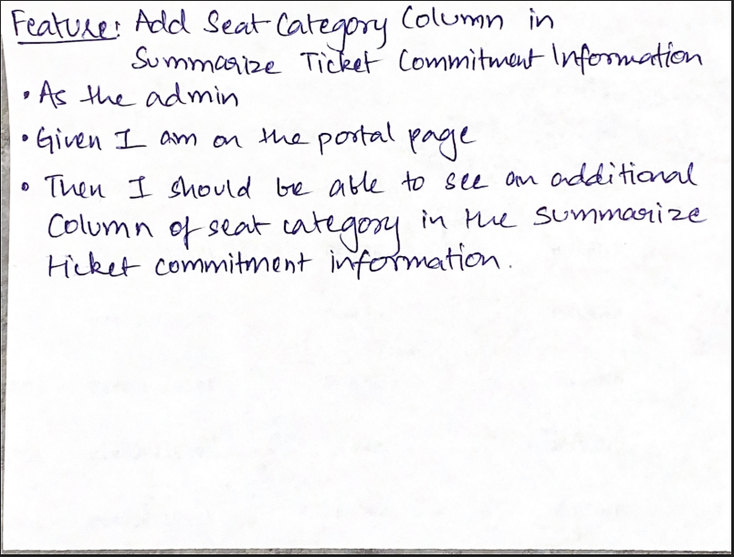

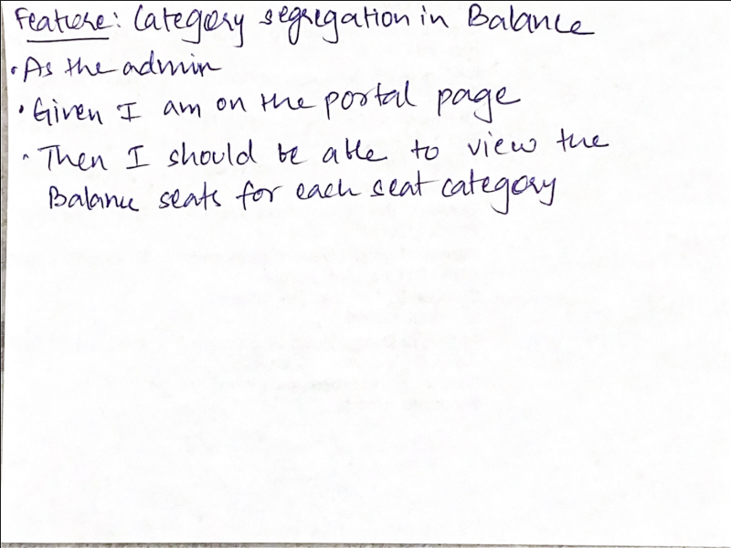 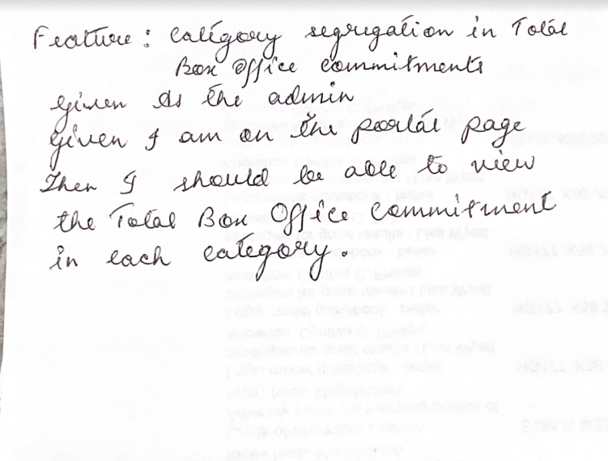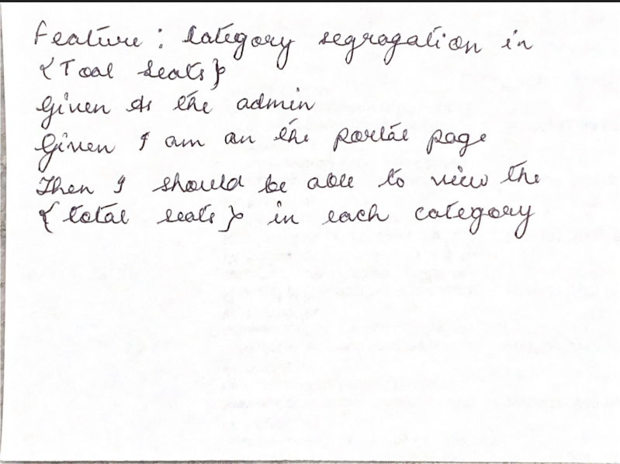 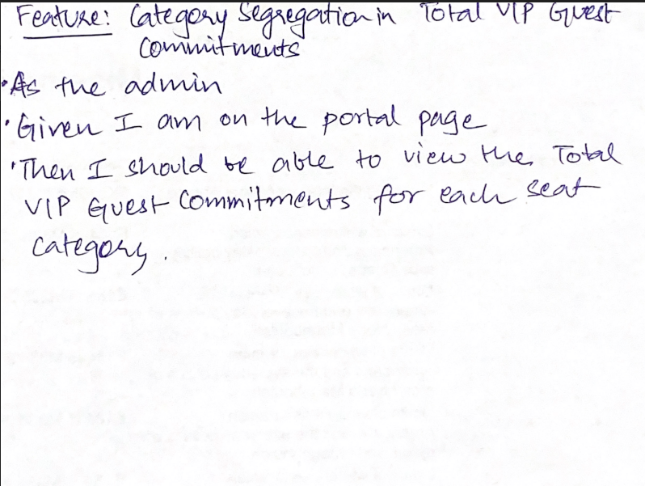

**UI StoryBoard:**

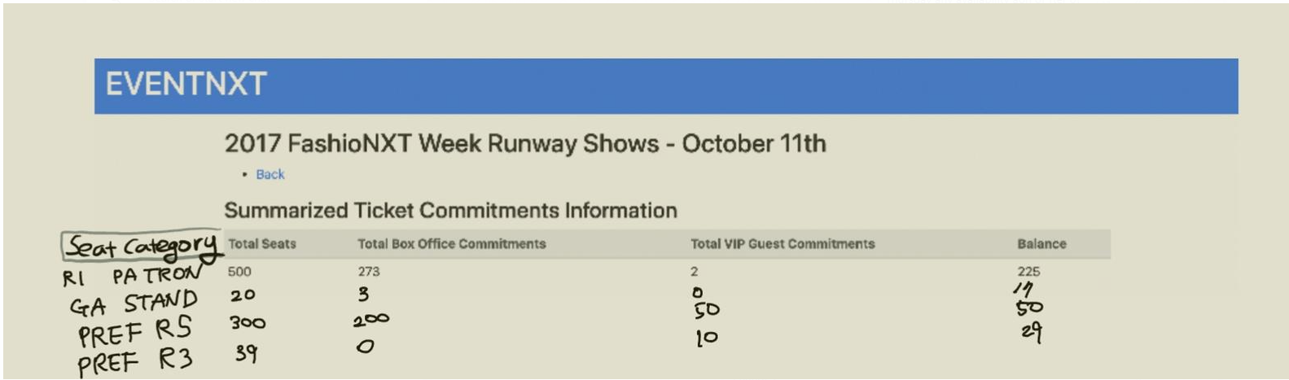

**Legacy Code:**

**Overall learning strategy for prior code**

1. Study the overall architectural and implementation strategy of the prior project by going through the project report and github repository code.
2. Understanding the front end components and backend components and database of the prior project.
3. Improve ruby knowledge by going through the SaaS textbook and presentation slides.
4. Understand the testing framework employed by the prior project.

**Improving strategies from prior code**

1. Improving the testing framework to find the bugs that are existing in the prior code.
2. Fixing the bugs that are found by modifying the code.
3. Adding the code that implements new features.
4. Adding test cases to check the newly added features work properly.

**Improvement of user stories**

1. (Old) As a VIP guest, I would like to submit the response form through the email link and receive the RSVP confirmation.

(New) As a VIP guest, I would like to submit the response form through the fancy email link which has graphics and customized text such as New York Fashion week's and receive the RSVP confirmation.

1. (Old) As an event owner, I would like to know how many VIP guests have provided feedback via confirmation email, so that the manager can send confirmation email again manually.

(New) As an event owner, I would like to know how many VIP guests of the particular seat category( 6 categories exist) have provided feedback via confirmation email, so that the manager can send confirmation email again manually.

**New user stories**

1. As an event owner, I would like to know how many seats from each category are booked and available, so that the manager can send an appropriate email to that particular seat category.
2. As an event owner, I would like to send a referral link to VIP guests, so that they can invite other guests and get rewards.
3. As an event owner, I would like to see the seat allotments of VIP guests and box office and total balance seats left in each category.
4. As an event owner, I would like to see an extra column which captures the seat category.